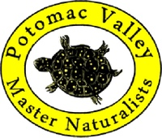
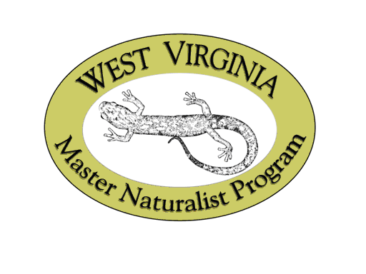
Potomac Valley
Master Naturalist Program
Sponsored by Potomac Valley Audubon Society & West Virginia Division of Natural Resources
2020 REQUEST FOR SCHOLARSHIP
Must be postmarked by January 31, 2020

Name (Last, First, MI) ____________________________________________________________________________
Mailing Address _________________________________________________________________________________
County _________________________________________ State ______________ Zip code (+ 4) _______________
Phones: Home ( _______) __________________________ Cell (________) ________________________________
E-Mail Profession/Type of Work ___________________________________

Have you already sent in a Master Naturalist application form? Yes _____ No ______
(If not, please submit that form with this application. It is available at www.potomacaudubon.org.)

The Potomac Valley Audubon Society and the West Virginia Division of Natural Resources are offering these classes as a service to the citizens of the area. Potomac Valley Master Naturalists offers the William Grafton Memorial Scholarship to Master Naturalist students who will use this opportunity to serve the community for many years to come, and for whom the total $300 fee would be an obstacle to participation. Scholarships may be full or partial.

As a Master Naturalist of West Virginia, you will use the skills and knowledge gained as a volunteer to provide stewardship of our natural resources and to promote public understanding through education and service efforts within your local community and the state of WV.

Application:
1) In an attached document, please explain your commitment to the program, previous volunteer experience, and your need for a scholarship. (Limit 500 words)

2) Have you already sent in a Master Naturalist application form? Yes____No_____
If not, please submit that form with this application (also due 01/31/20). It is available at www.potomacaudubon.org.

I understand that the total fees for the Potomac Valley Master Naturalist program are $300 per student and that I am responsible for paying any balance not covered by any scholarship I may receive. I realize that scholarship recipients are expected to complete their training and volunteer hours within 4 calendar years and remain active in PVMN for at least 2 years after completing the required courses and volunteer hours. Failure to do so may result in my re-payment of scholarship funds.

________________________________________________________________ __________________
Signature Date

Please submit application to:
PVAS, PO Box 578, Shepherdstown, WV 25443, RE: PVMN Scholarship Fund
The Potomac Valley Audubon Society (PVAS) does not exclude, deny benefits to, or otherwise discriminate against any service recipient, applicant, Program Staff, or the public on the basis of race, color, national origin, disability, age, sex, political affiliation, or religion. Further, PVAS acknowledges that it is unlawful to retaliate against any person who, or organization that, files a complaint about such discrimination.

